Create a Date from date table from Power Bi data set in Power Query

* From data table select only date,remove other column.
* Name table StartDate, and from Transform tab in Date tab you create earlydate, if you have different eary date in the same tab from tranformtab in data set you can change start of year, the same is for end of year. Thie mean that atumotaicaly can change data when we can uploadit from DATA.
* In Home tab you select New Source 🡪Blank Query to navigate New Data Table.

First we must to create to list from StartDate and EndDate.

Formula:

={1..4} enter 🡪 create list

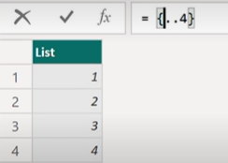 Than you must to change number 1 and 4 from formula:

 press enter and you create a new list:

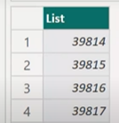This number present how many days are from first of January to end of date.

We need it to convert from List to date.In Transform tab you can see icon To Table 🡪 click on it,

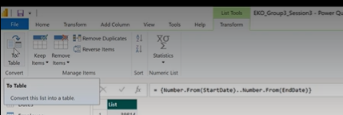

ang you can find option and Select OK.

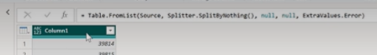

And change your data column to Data type Date.

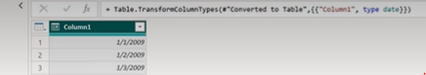

Rename column in Date

If you can go on tab Tranform you only can transform data in new one, but if you go on AddColumn you can add new column , and from date tab you can navigate what you need.

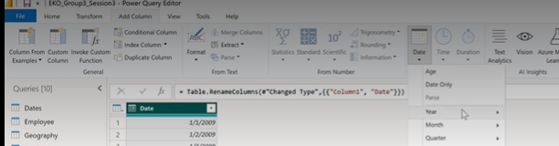

Click CloseAnd Aplly in the data basa. Go to the model view, find this calendartable and create connection with sales table, where you select table to create a new one data table.

(The connection should to be from Sales(data) to Calendar(data).